4.1) Write a JavaScript to validate the following fields in a registration page created in week 2

a. Name (start with alphabet and followed by alphanumeric and the length

should not be less than 6 characters)

b. Password (it allows alphanumeric, special symbols and should not be less

than 6 characters)

c. E-mail (should not contain invalid email addresses)

<!DOCTYPE html>

<html>

<head>

<meta charset="utf-8">

<title>Form Validation</title>

<script language= "javascript">

function validation()

{

var x=f.un.value;var len=x.length;

var val=x.charCodeAt(0); var p=f.pw.value;

var c=f.cpw.value;var a=f.email.value;

var atpos=a.indexOf("@");var dotpos=a.lastIndexOf(".");

if(len<6||x==""||x==null)

{

alert("check your username! must be minimum 6 characters");

}

else if(val<65 || val>90&&val<97 || val>122)

{

alert("username must be begin with an alphabet");

return fasle;

}

else if(p==" || c==" || p.length<6 || c.length<6 || p!=c)

{

alert("password and confirm password should be same and greater than 6 characters!");

return false;

}

else if(atpos<6 || dotpos<atpos+6 || dotpos+2>=a.length)

{

alert("Not a Valid email id");

return false;

}

else

alert("Congratulations!you have submitted successfully");

}

</script>

</head>

<body bgcolor="skyblue">

<center>

<h1> REGISTRATION FORM </h1>

<table style="border:1px solid" bgcolor="lavender">

<form name="f" action="4N.html" onsubmit="return validation();" method="post">

<tr>

<td><label>Username</label></td>

<td><input type="text" name="un" placeholder="Please Enter Name"></td>

</tr>

<tr>

<td><label>Password</label></td>

<td><input type="Password" name="pw" placeholder="Please Enter password"></td>

</tr>

<tr>

<td><b>Confirm Password</b></td>

<td><input type="password" name="cpw" placeholder="Please enter password again"></td>

</tr>

<tr>

<td><label>E-Mail</label></td>

<td><input type="text" name="email" placeholder="Please enter email"></td>

</tr>

<tr>

<td><label>Phone Number</label></td>

<td>

<input type="text" name="country code" value="+91" size="2"/>

<input type="text" name="phone" size="10" requires="on" placeholder="Enter phone Number"/>

</td>

</tr>

<tr>

<td><label>Gender</label></td><br>

<td>

<input type="radio" name="male"/>Male<br>

<input type="radio" name="female"/>Female<br>

<input type="radio" name="other"/>Other<br><br>

</td>

</tr>

<tr>

<td><label>Date of Birth</label></td>

<td><input type="date" name="dob" id="date" required="on" placeholder=" "/></td>

</tr>

<tr>

<td><label>Languages Known</label></td><br>

<td>

<input type="checkbox" id="language1" name="language1" value="English">

<label for="language1"> English </label><br>

<input type="checkbox" id="language2" name="language2" value="Telugu">

<label for="language2"> Telugu </label><br>

<input type="checkbox" id="language3" name="language3" value="Hindi">

<label for="language3"> Hindi </label><br>

<input type="checkbox" id="language4" name="language4" value="Tamil">

<label for="language4"> Tamil </label><br><br>

</td>

</tr>

<tr>

<td><label> Address </label></td><br>

<td><textarea cols="80" rows="5" value="address" placeholder="Please Type your Addesss"></textarea></td>

</tr>

<tr>

<td><center><input type="Submit" name="Submit"></center></td>

</tr>

</form>

</table>

</center>

</body>

</html>

Ouput :

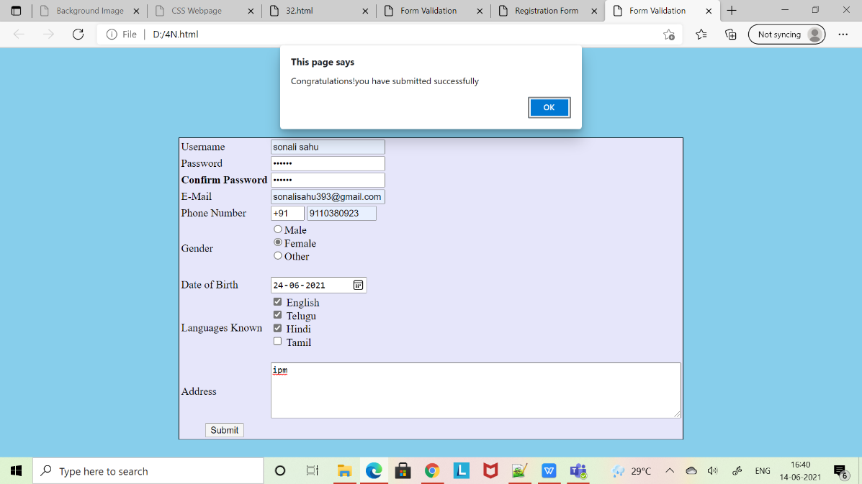

NAME : Sonali Sahu

18A91A0556